Employee Login: INOVA-0013 – Password: Pass@123
Manager Login: INOVA-TL-3388343 – Password:
PersonalMy Resignation
- In Create Mode Required for Request Status in Dropdown required Now System IS default in Draft Mode
( attachmeht paramter and request status id parameter need to add in post api )
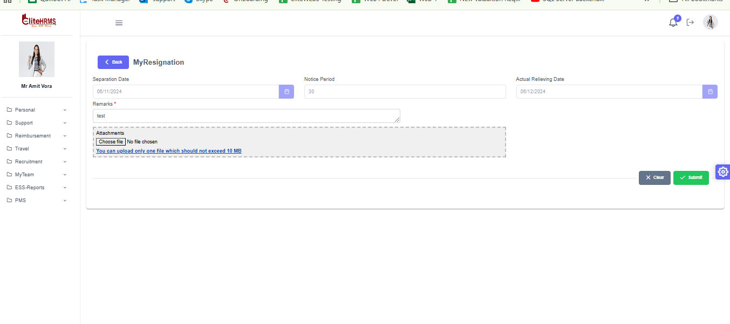
Approval Routing is not working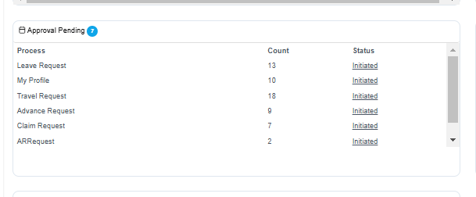

Personal Loan Entry Request
- In Create Mode Default to loaded Current Date in Loan Request Date
- Effected Payroll Month to loaded Current Month
(Need dafault value in below api for above 2nd point
https://web3essapi.elitehrms.in/api/admin/GetLoadDataSource?DataSource=Periods&WAID=2604
authorization: f1f9c272-eb5d-40d8-8487-e4f1135e45a2
DefaultValue: ""
)
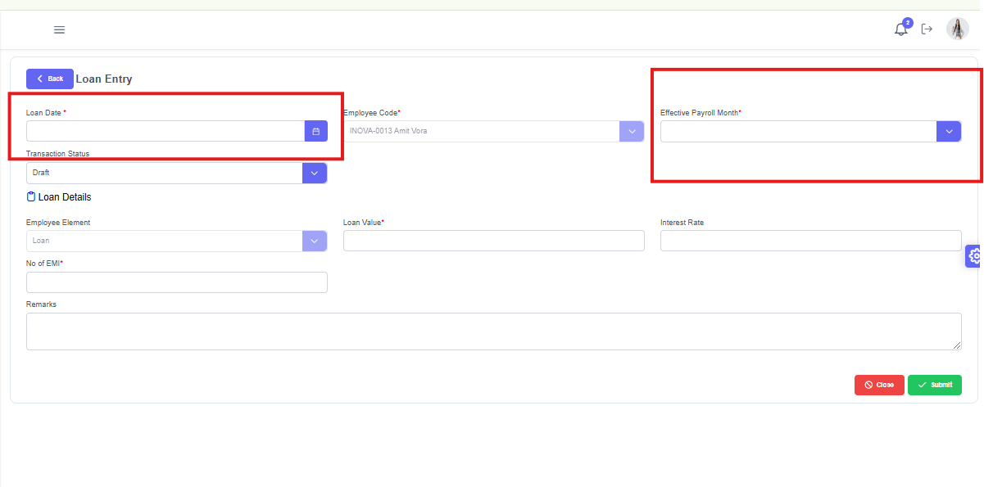

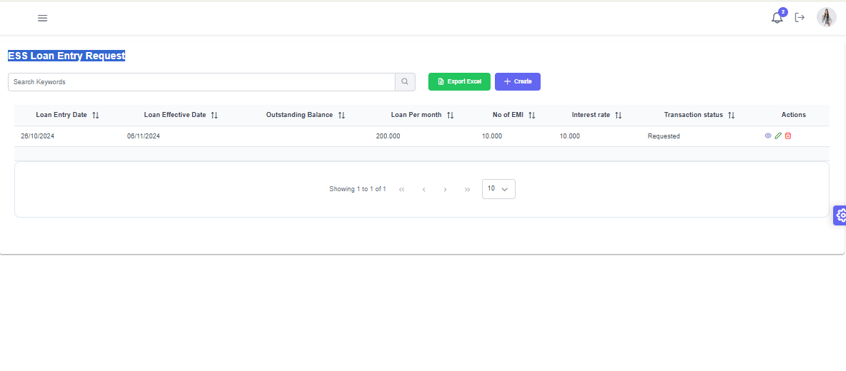3. Workflow Configuration done for Loan Entry
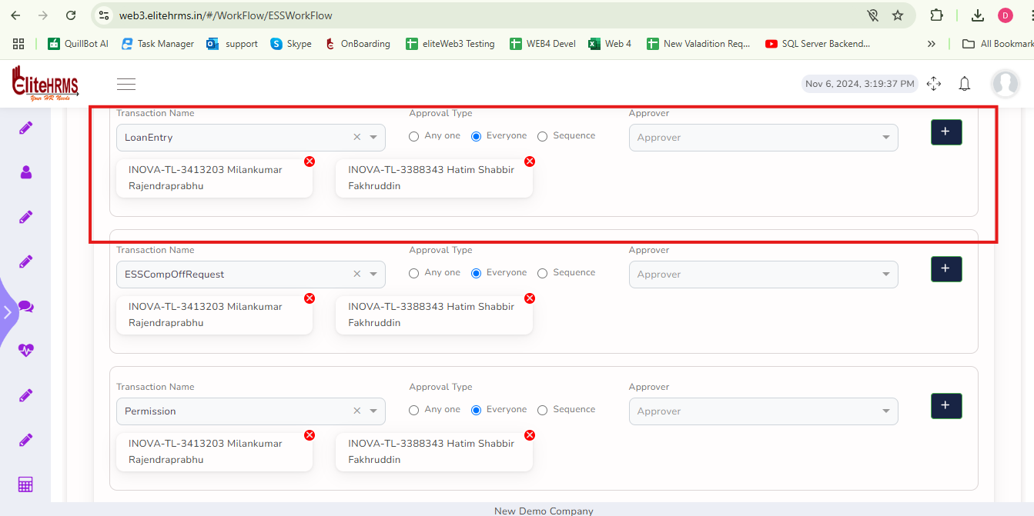
Approval Routing Is not Working
Approval Record is not Show in Team Head login - INOVA-TL-3388343
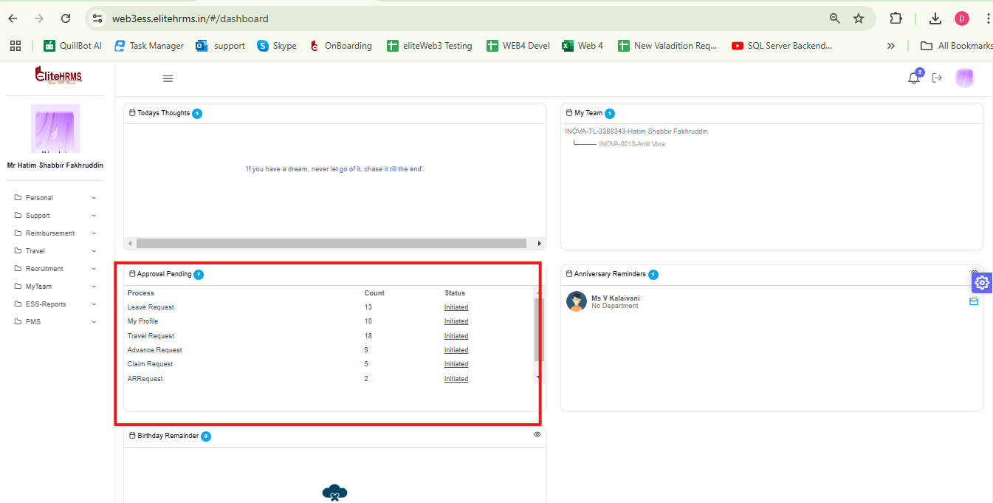

Personal ESS Comp off Request

Employee Login

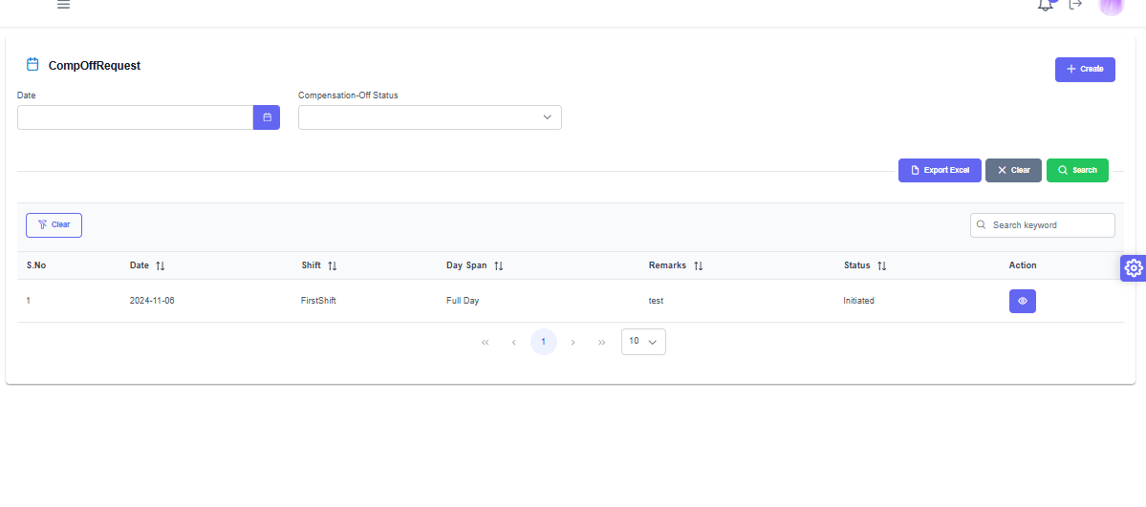

Approval Routing Is not working

Approval Records is not Show in Team Head login - INOVA-TL-3388343

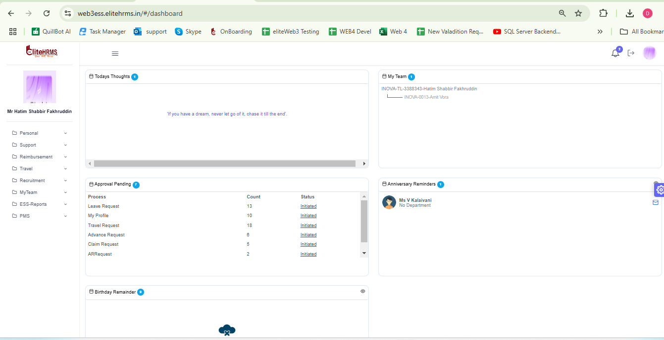

Support INFRASUPPORT REQUEST

In Search Page is not loaded below information
- Request type
- Request Status
- Action taken Status
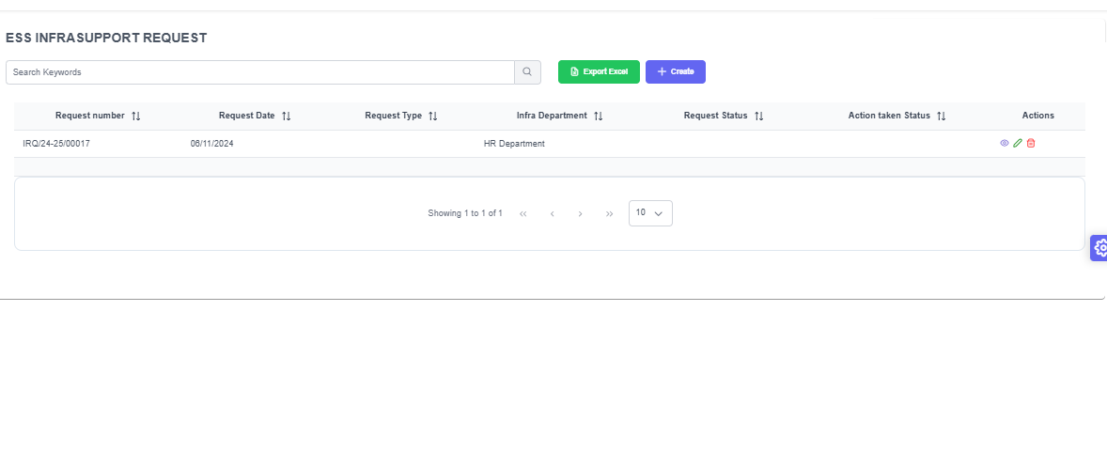

Support Policy and Document
File is how But Downloaded it show Error
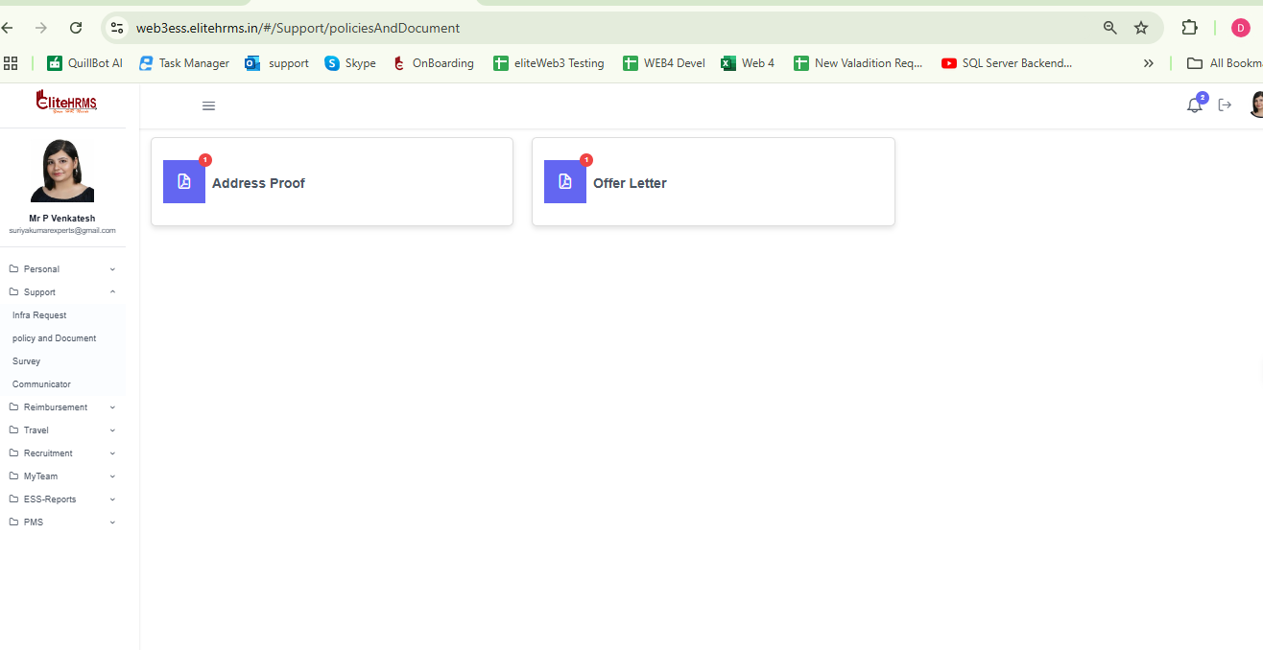

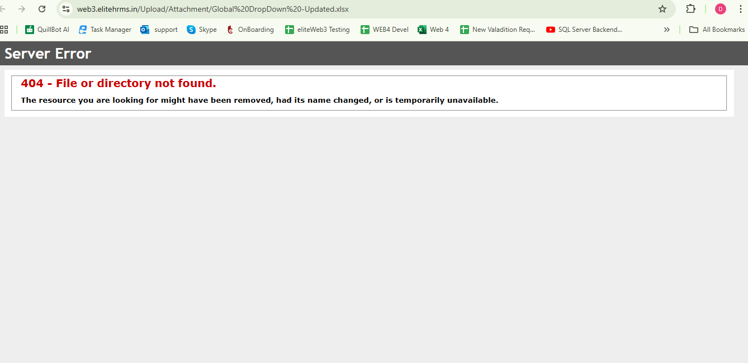

Support - Survey Save button is not working
( https://web3essapi.elitehrms.in/api/admin/PostSurveyEmployeeFeedBack
404 Not Found )

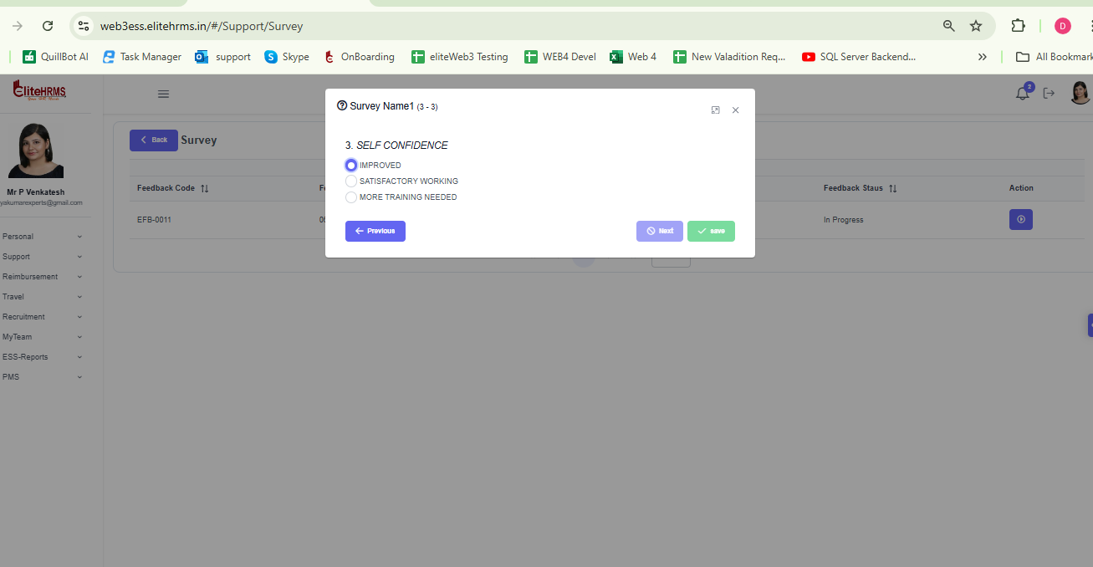

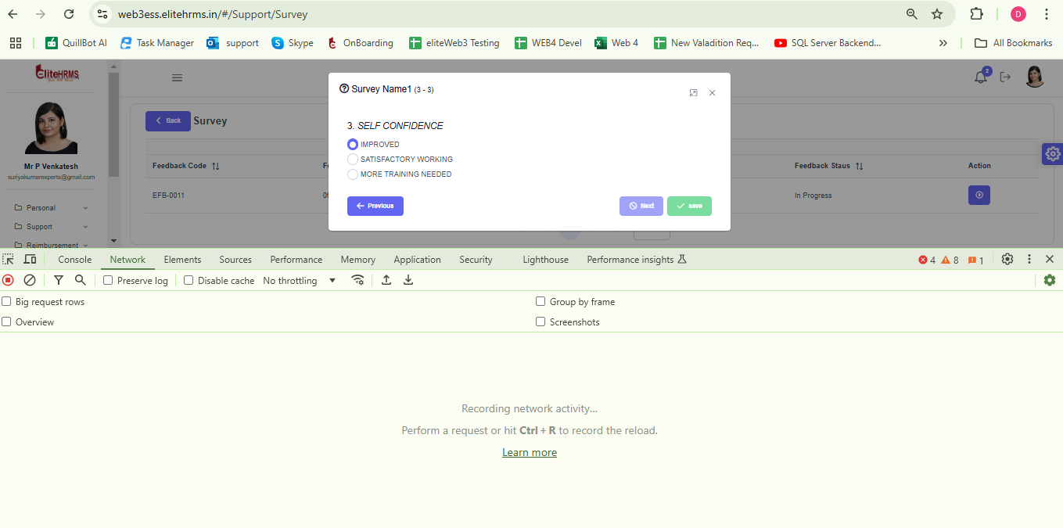

Support- Communicator
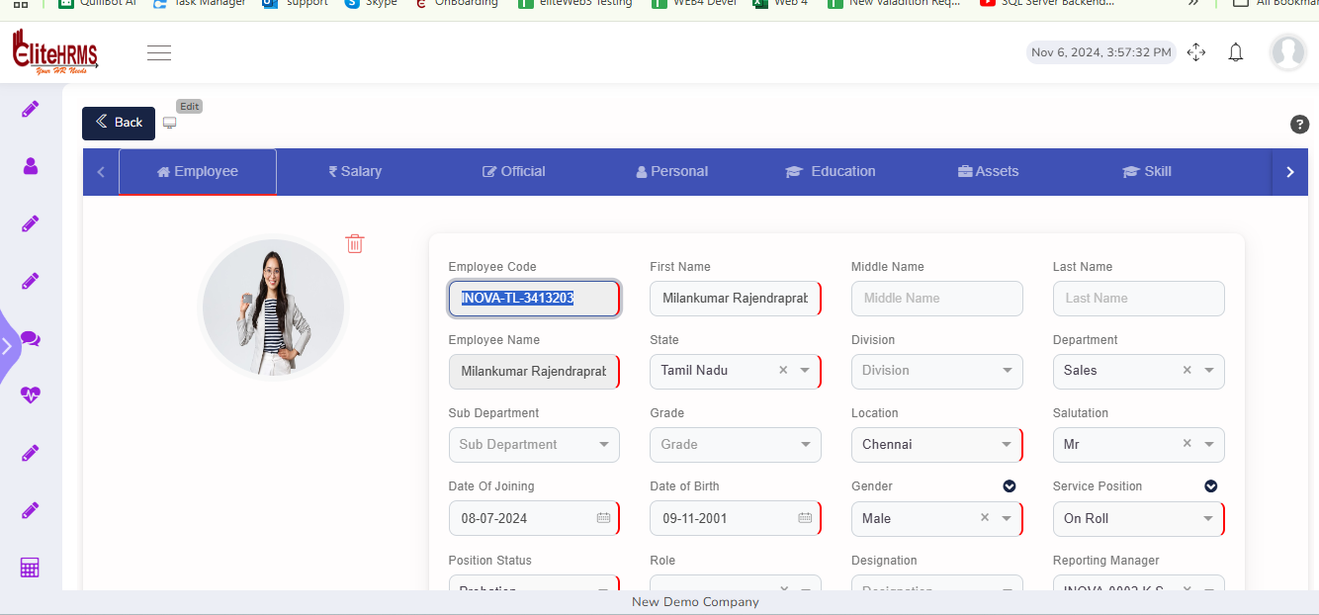
Image is not Show
(
https://web3essapi.elitehrms.in/api/Support/GetOrgCommunicatorDetails?EmployeeCodeandName=subra&Location=&Department=&Division=&Grade=&Costcentre=&Role=&Designation=&SubDepartment=
authorization: 31719f93-82c6-49f6-94c8-0a64702eb7eb
OrgCommunicator : [
ImagePath: "https://web3.elitehrms.in\\Upload\\ItemCatalog\\UserProfile\\"
]
This Above api’s image path value need to change like below format
https://web3essapi.elitehrms.in/api/Personal/getUserProfile
UserDetails :[
ImagePath: "https://web3adminapi.elitehrms.in/Uploads/2024/10/24/3980b53c-6f9e-4fb1-bdec-5c04127293fc_filename.png"
]
)
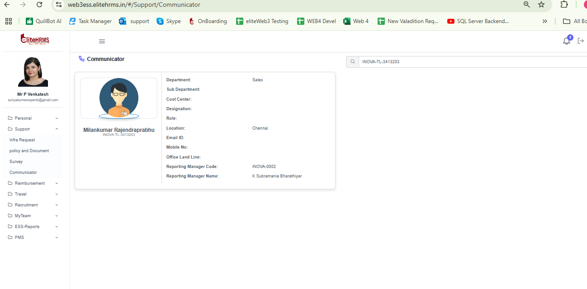

Reimbursement LTA Claim Request

ADD and Edit is not Working for inside table
Post and get apis not working
(Post and get apis pending for this screen
https://web3essapi.elitehrms.in/api/Personal/PostLTAClaimRequest
404 Not Found
https://web3essapi.elitehrms.in/api/Personal/GetLTAClaim?LTAClaimGUID=95df26a0-de47-4736-a2ca-00a3ac34264f
404 Not Found
)
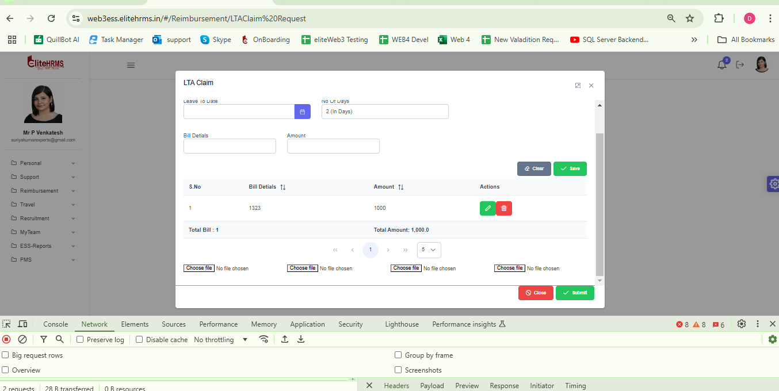

Reimbursement Travel Reimbursement Summary

ADD and Edit Is not working
- KMS paramter issue and attachements issues pending.
- Update modepost api showing 999 error)
https://web3essapi.elitehrms.in/api/Reimbursement/PostTravelRequest
{
"LocalRequestGUID": "907bc4cb-03d1-43eb-aad7-458f7f4baaec",
"RequestNo": "TLR/24-25/00011",
"RequestDate": "2024-07-11",
"TotalAmount": "200.00",
"Period": "1677",
"Attachment1": "21b3b5df-d438-4d12-82e9-d38ec8f6f7dc",
"Attachment2": "c2889cc0-17bb-416e-82c2-0678a7d9fea2",
"Attachment3": "76a1bf82-92ae-485e-ad91-1495550c262a",
"Attachment4": "2a9b1c64-2a6b-4809-96e5-e287ba48d758",
"SubmitRequest": "0",
"TravelRequestDetails": [
{
"LocalRequestDetailguid": "3301b735-ff65-66b8-021f-19f3b5872920",
"RequestDate": "2024-11-07",
"FromLocation": "chennai",
"ToLocation": "anna nagr",
"TransportID": "6630",
"Kilometer": "0.00",
"Amount": "200.00",
"Remarks": "testing on 07/11/2024",
"Attachment": "cdd7b64d-de40-4461-a9b5-b5b5f3f7e806"
}
],
"RequestGUID": "06c66524-8bd8-b79c-ebba-25964f3fafbe",
"PeriodID": "1677"
}
{
"_status": "Failed",
"_code": "999",
"_Source": "PostTravelRequest",
"_Description": "Exception Occured",
"_Details": "Object reference not set to an instance of an object.",
"_TransID": null,
"_Timestamp": "20241107181024"
}

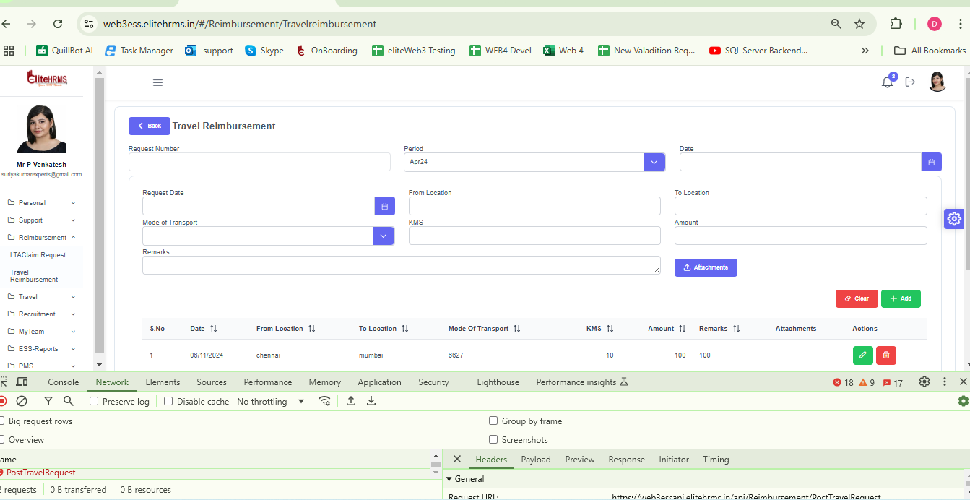

Travel- Travel Request - Working fine
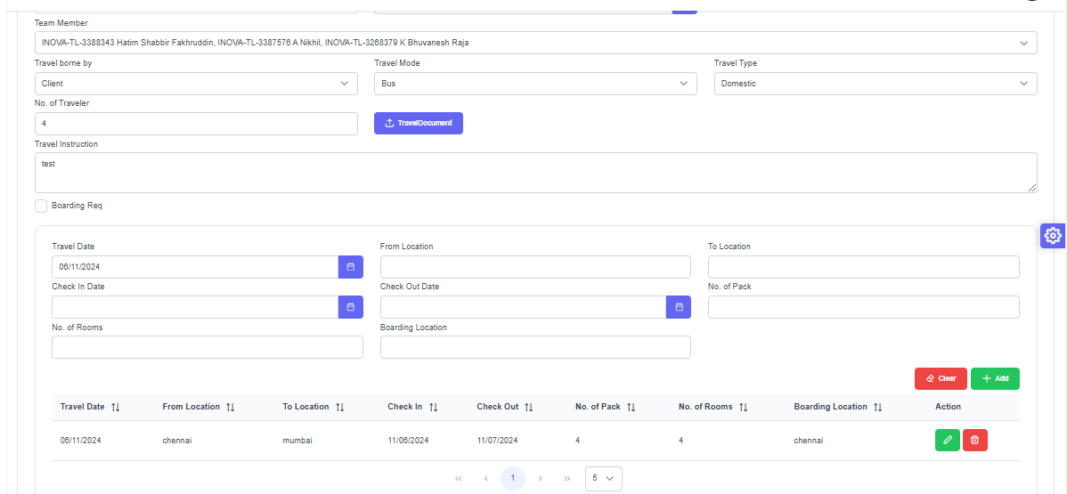

Approval routing working fine

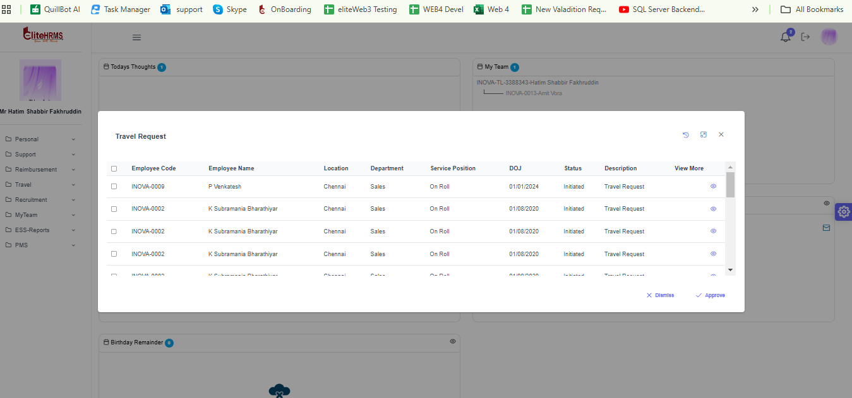

Travel Travel Advance Request

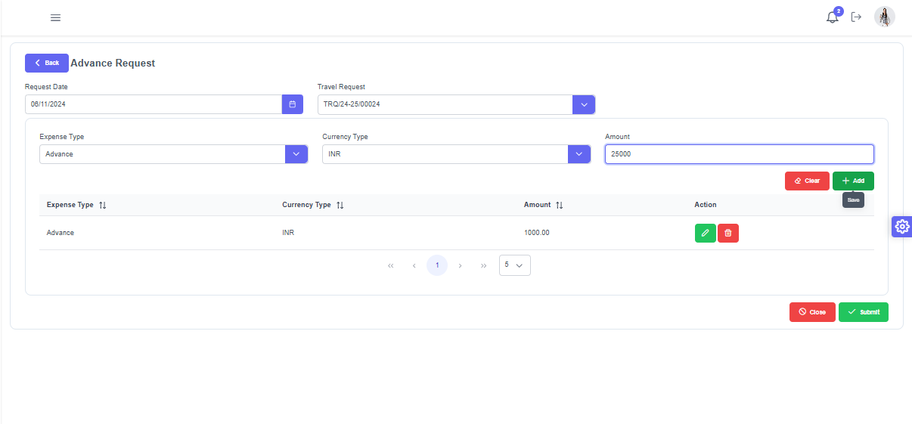

While Add button Click is not show Expense Type Currency Type in the Grid
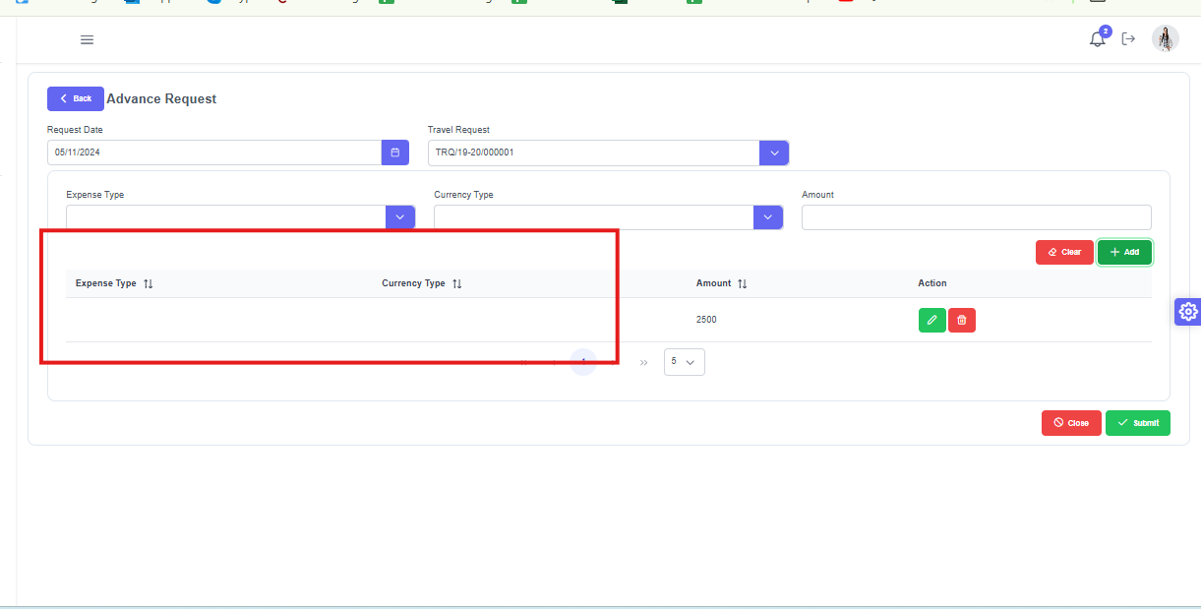

Travel Travel Claim Request

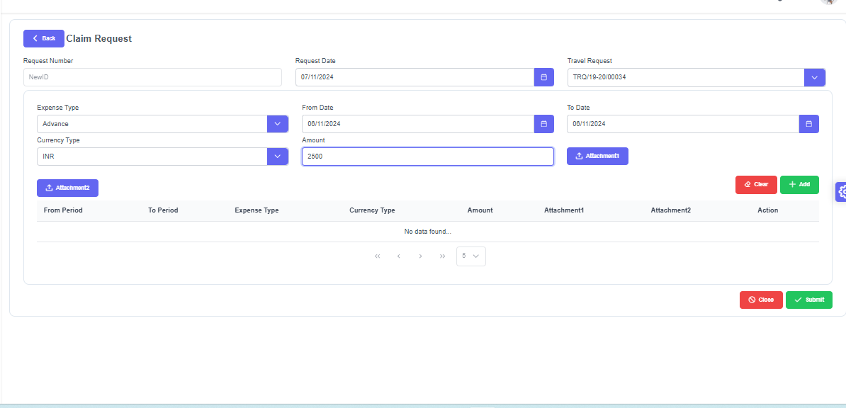

While Add Button click Grid Values is not show Expense type Currency Type
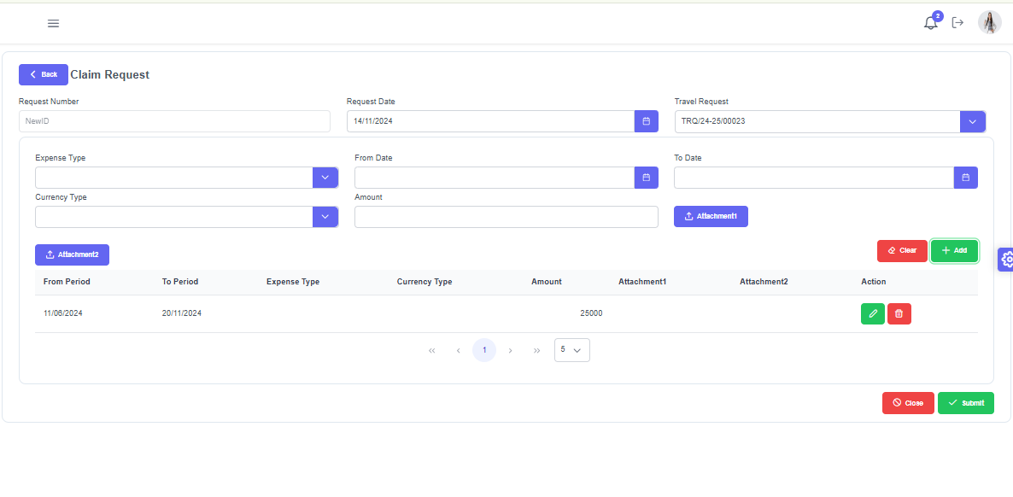

Search Page is not Show Amount, Advance Amount, and Balance Amount Currency Type 